|  |  |
| --- | --- |
| User MANUAL  SUB (See Unstable Buildings) | Hugo BALTZ |
|  |  |

Table of Contents

I. How install SUB? 2

II. How launch SUB? 3

III. How does SUB work? 4

# How install SUB?

S.U.B. is not available on the PlayStore, so you have to install directly the .apk on your device. First, you have to allow installation of apps from unknown sources, there are the steps to achieve it:

1. Go on the device’s settings.

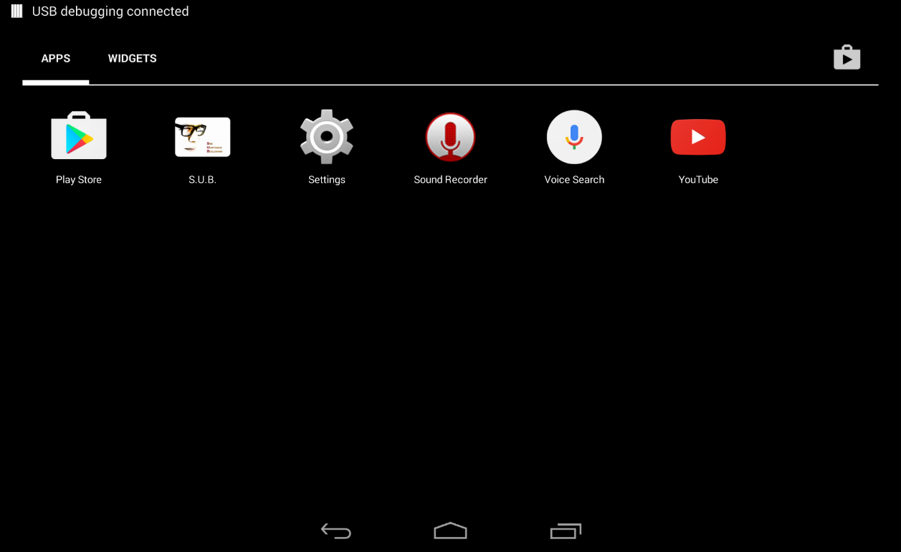

1. Then go on Personal/Security:

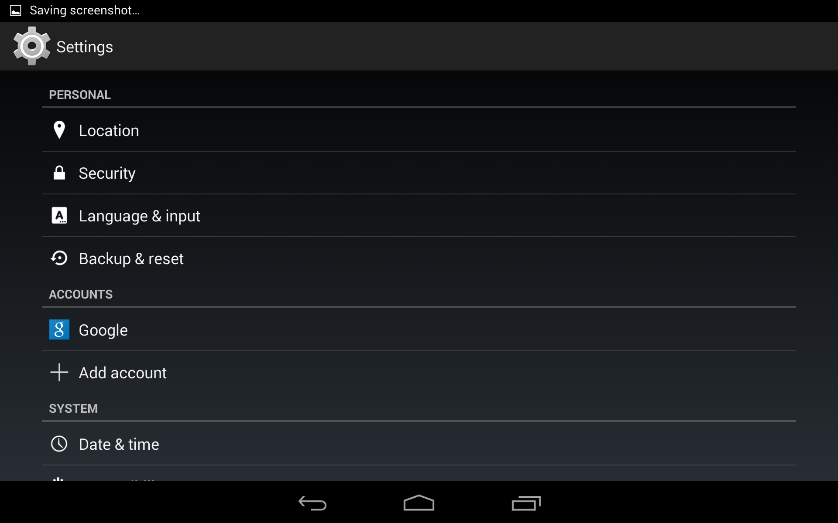

1. Then on Device administration allow Unknown sources:

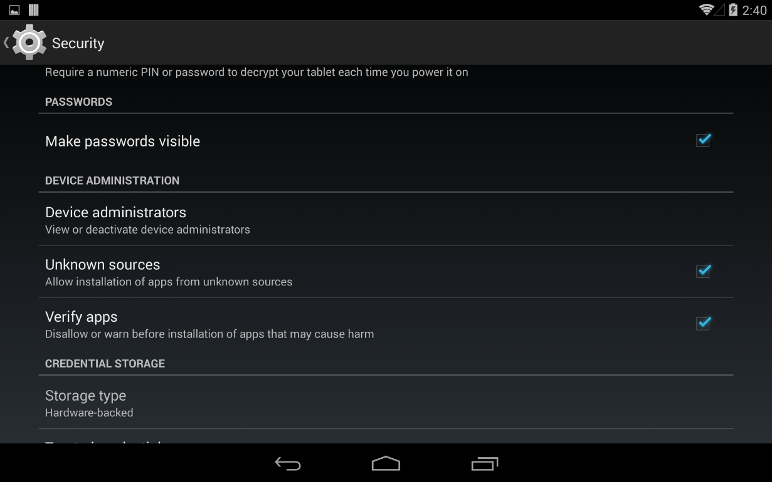

1. You can download the apk file here with your device
2. When the download process is finished, you just have to open the apk files, your devices will install it.
3. To work, the application will need some files (you can find them here), you have to put these files on the root of your SDcard in a folder call sub.

# How launch SUB?

To launch the application, you just have to click on the icon on your device:

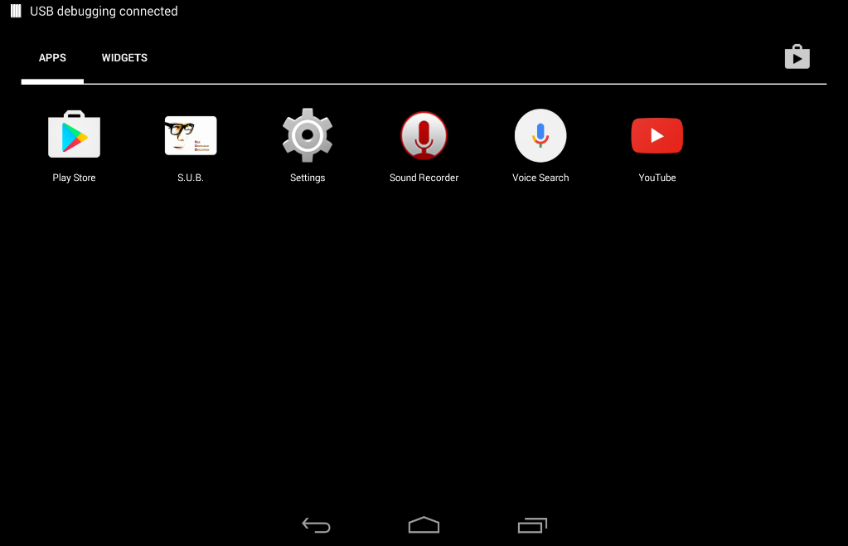

# How does SUB work?

SUB is an Augmented Reality application, so all you have to do is to look around you.

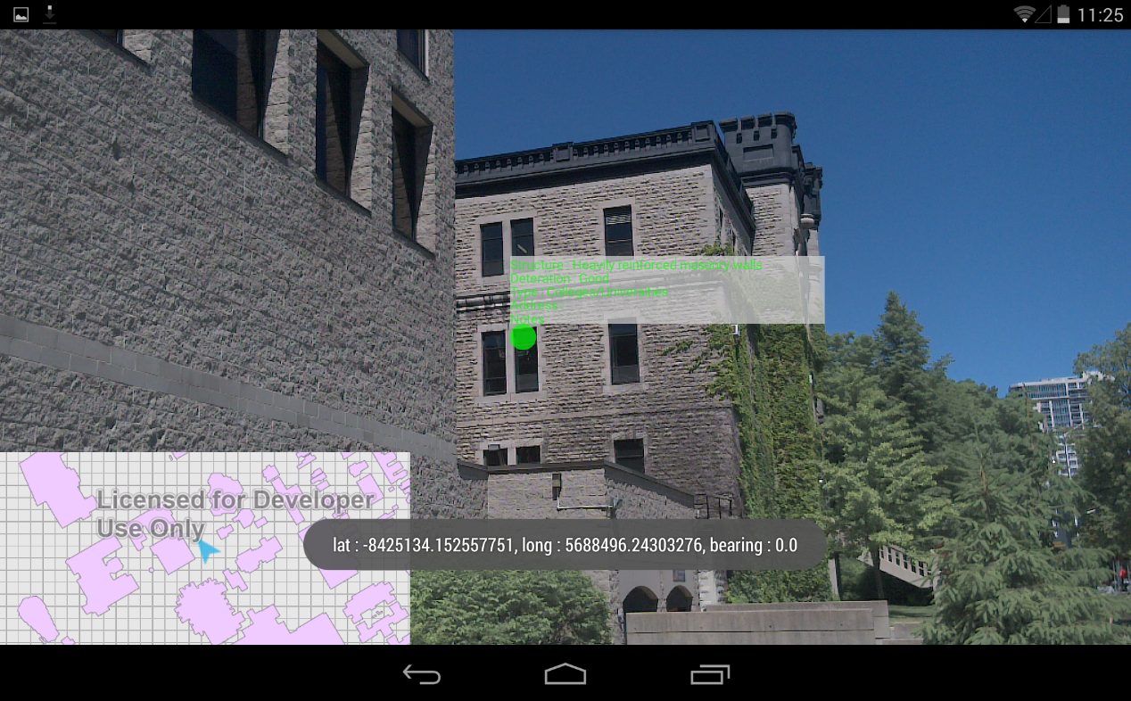

There, you have your location and you can see the shape of the buildings around you

There, you can see some information about the buildings that are in your visual field

You can access the menu by moving you finger on the screen (up to down), then you can choose what information you want to see:

* The footprints of the building around you
* The geological information in a radius of 200 meters around you
* The fault lines

